2020-2021 MIDDLE SCHOOL TENNIS UNIFORM ORDER FORM

PLAYERS NAME: _______________________________________
CIRCLE THE SCHOOL YOU ATTEND: N. RIDGE N. RICHLAND

Instructions: Please fill in the spots stating how many you want, what you want, etc. If you do not want any of those specific items then leave it blank or put NONE. At the bottom is where you write the total cost amount of everything you owe.
Payment: You can pay cash or check. Make the checks out to RHS Tennis. Payment can be turned in at time of pick up.
When will I receive my order? I am hoping to get all that you ordered to you by the end of August or at our Parent/Player meeting on August 15th!
Total You Owe: ________________________________________
PS. Please be sure to tell me if it is an adult or youth size. Also parents are able to order anything too.
PICTURE | WHAT IT IS USED FOR | SIZES NEEDED  (PLEASE INDICATE IF IT IS A YOUTH OR ADULT & HOW MANY YOU WANT) | COST PER  SIZE | TOTAL COST  (You write in here your total that you owe)
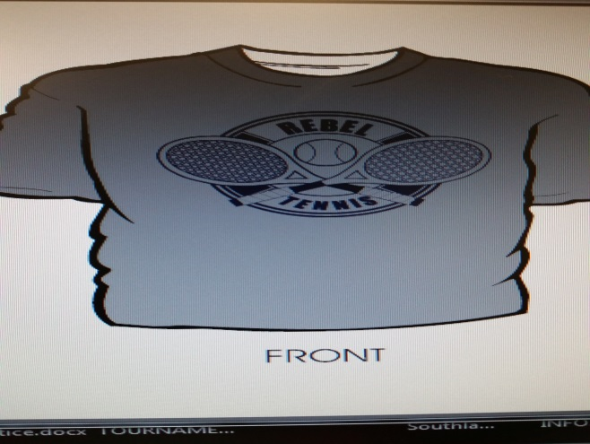 | This is used for our matches after school. It will be a dri-fit shirt. It will be grey with navy lettering on the front. You can get this in youth or adult sizes.  Yes you must get this one! |  | $10
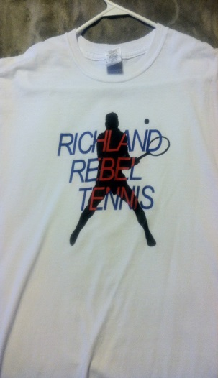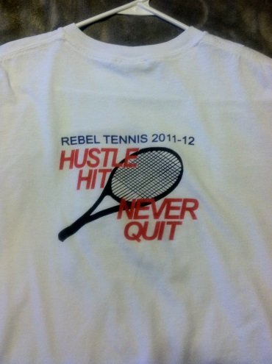 | This is a white cotton shirt that you wear to school on the day of our match. It has navy, blue, and red lettering. This way you represent our sport on match day!  The picture shows the front & back!  (The year will be different)  Yes you must get this one! |  | $15
PICTURE | WHAT IT IS USED FOR | SIZES NEEDED  (PLEASE INDICATE IF IT IS A YOUTH OR ADULT & HOW MANY YOU WANT) | COST PER  SIZE | TOTAL COST  (You write in here your total that you owe)
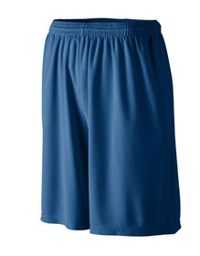 | This is the boy’s shorts that they will wear for their match. They will be Red colored. They will have pockets & a draw string inside.  Yes you must get this one! |  | $10
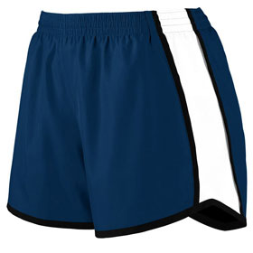 | This is the girl’s shorts that they will wear for their match. They will be RED colored with a white stripe on the side.  Yes you must get this one! |  | $10
 | Our Sport-Wick technology transforms anti-static fleece into an excellent warm up and cool down option. Your top layer releases moisture from inner layers, while keeping your skin comfortably dry.  - 100% polyester  - Tag-free label  - Three-panel hood  - Self-fabric hood lining  - Taped neck  - Dyed-to-match drawcord with metal tips  - Front pouch pocket  - Self-fabric cuffs and hem |  | $30  TOP
$30

BOTTOM
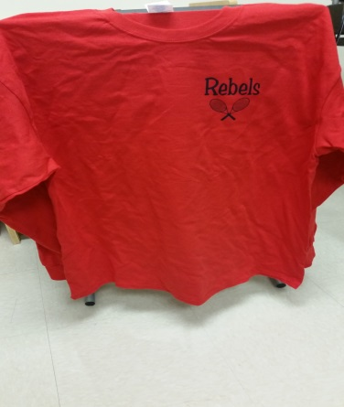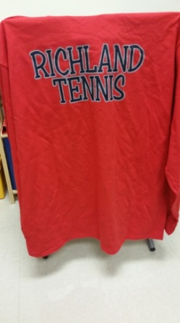 | This is a long sleeve cotton shirt that was popular this year. The long sleeve shirt will be red with navy lettering.  This is optional! |  | $20
PICTURE | WHAT IT IS USED FOR | (PLEASE INDICATE HOW MANY YOU WANT) | COST PER  SIZE | TOTAL COST  (You write in here your total that you owe)
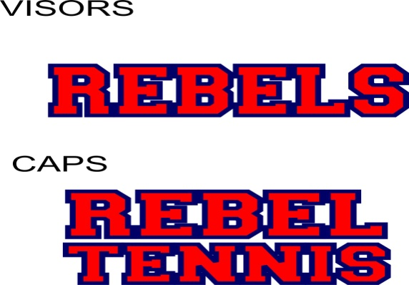 | These are logos that we put on our hats. Our hats are frayed at the bill. You can get the hat in white or navy.  Please be sure to tell me which color hat you want (White or Navy) & if you want it in a hat or visor!  Also we can get them in a visor!  Lettering is as appeared.  This is optional! |  | $20
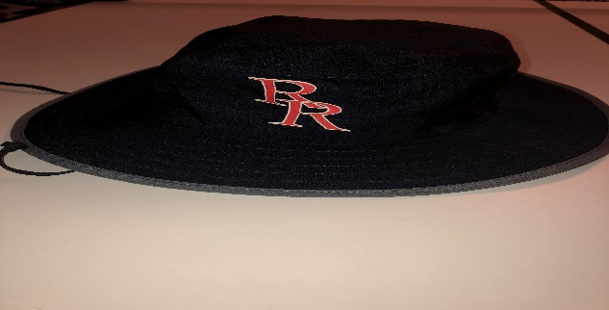 | REBEL BUCKET HAT |  | $20

ADD UP AND PUT TOTAL AMOUNT AT THE TOP OF THIS DOCUMENT.

EMAIL THIS TO COACH JOHNSON FILLED OUT COMPLETELY
chris.johnson@birdvilleschools.net

